**Transportation**

1. **From Taoyuan Airport**If you arrive at Taoyuan airport in Taiwan, there are three steps to reach the workshop venue:
   1. **From Taoyuan Airport to Taipei Railway Station.(Bus, THSR, Taxi)**
   2. **From Taipei Railway Station to Hualien Railway Station.(Railway)**
   3. **From Hualien Railway Station to Dung Hwa University.(Shuttle)**
2. **From Taoyuan Airport to Taipei Railway Station**There are three ways to reach Taipei Railway Station from Taoyuan Airport. You can follow the map of terminal I and terminal II to find the way to take Taiwan High Speed Railway, bus, or taxi.
   * + 1. **Arrival at Terminal I**

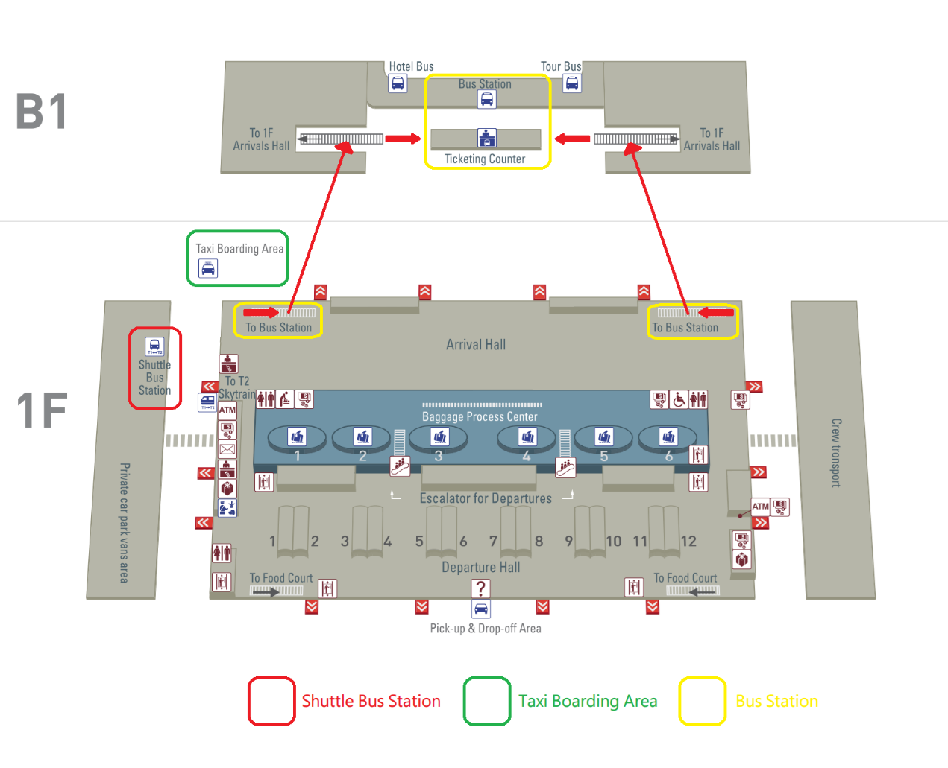

* + - 1. **Arrival at Terminal II**

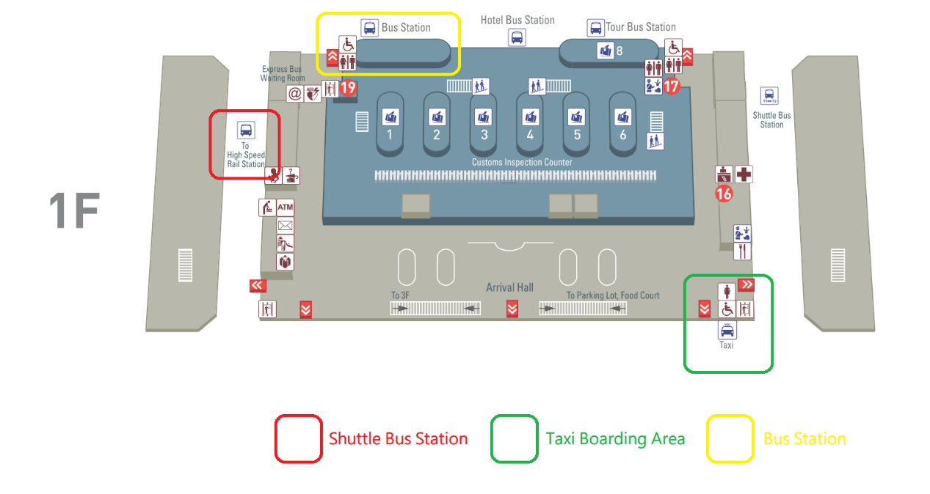

1. **Taiwan High Speed Railway:**To arrive Taipei by Taiwan High Speed Railway, you can book a seat online or buy the ticket just before you get on the train. From airport to high speed railway, you can take the shuttle at UBUS service counters at Arrivals Lobby of Terminals 1 and 2. The price of the ticket is 30 NTD, and the trip length is about 25 minutes. The following is the map inside the station:  
   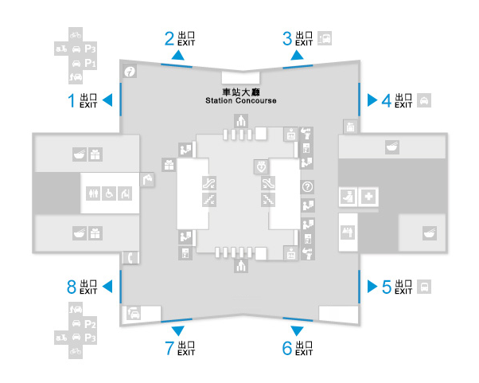  
   The following is the website for booking tickets, and the system provides on-line reservation for the train for which the departure date is no more than 28 days:  
   [**https://irs.thsrc.com.tw/IMINT/**](https://irs.thsrc.com.tw/IMINT/) **(中文訂票網站)**[**https://irs.thsrc.com.tw/IMINT?locale=en**](https://irs.thsrc.com.tw/IMINT?locale=en) **(Englishbooking website)**[**https://irs.thsrc.com.tw/IMINT?locale=ja**](https://irs.thsrc.com.tw/IMINT?locale=ja) **(日本語チケット予約)**
2. **Bus:**

To arrive Taipei Railway Station y bus, you can buy the ticket at bus counters in the airport. And go to the bus pickup points to get on the bus.

Terminal 1 bus pickup point: Bus pickup zone at B1 Arrivals.

Terminal 2 bus pickup point: Bus pickup zone at the northeast arcade of the 1st floor Arrivals lobby.  
You can take the “1819” to Taipei Main Station and “1961 West Bus” to Taipei Railway Station, while the price of the ticket is about 90-140 NTDs.

1. **Taxi:** Taxis operating by shifts are located at the west side of the Terminal 1's and Terminal 2's Arrivals Lobby at the Taoyuan International Airport. All taxis and drivers must pass a strict evaluation process by the Aviation Police Office before being allowed to service airport travelers. The comprehensive management protocol ensures safety for all travelers.

Taxi fare is based on the meter, highway tolls not included. Taxis will also transport passengers throughout all of Taiwan according to passenger need. Fares are charged according to standard rates.

You can show the sentence to the driver to bring you to Taipei Railway Station:

“請把這位貴賓送到台北火車站，謝謝。”

1. **From Taipei Railway Station to Hualien Railway Station**

You can arrive at Hualien Railway Station from Taipei by train. The following is the website to reserve the train tickets:

[**http://railway.hinet.net/**](http://railway.hinet.net/) **(中文訂票網頁)**

[**http://twtraffic.tra.gov.tw/twrail/**](http://twtraffic.tra.gov.tw/twrail/)**(中文時刻表)**

[**https://ticket.chinatrust.com.tw/railway/index.php**](https://ticket.chinatrust.com.tw/railway/index.php) **(訂票付款網站)**

[**http://railway.hinet.net/net_eng.htm**](http://railway.hinet.net/net_eng.htm) **(English booking website)**

[**http://twtraffic.tra.gov.tw/twrail/English/e_index.aspx**](http://twtraffic.tra.gov.tw/twrail/English/e_index.aspx) **(English Timetable)**

[**https://ticket.chinatrust.com.tw/railway/index.php**](https://ticket.chinatrust.com.tw/railway/index.php) **(Payment website)**

[**http://railway.hinet.net/ja_JP/net_eng.htm**](http://railway.hinet.net/ja_JP/net_eng.htm)**(日本語チケット予約)**

With prior communication, we shall reserve the ticket for you to reach Hualien railway station. Please just let us know your travel plan before 2015/06/20, so that we can arrange the ticket for you. If this is the case, you will get the ticket at the lobby in 1st floor, where you will find some staffs to help you. Kindly use the below link to reserve your train ticket.  
<http://ppt.cc/xbh~> (Train Ticket Reservation website)

|  |  |  |  |  |  |
| --- | --- | --- | --- | --- | --- |
| Number | Type | Train I.D | Departure Time from Taipei | Arrival Time to Hualien | Price |
| 1 | 太魯閣 | [280](http://twtraffic.tra.gov.tw/twrail/SearchResultContent.aspx?searchdate=2015/04/20&traincode=280&trainclass=%E8%87%AA%E5%BC%B7&mainviaroad=1&fromstation=1008&tostation=1715&language=) | 09:40 | 11:50 | $ 440 |
| 2 | 普悠瑪 | [222](http://twtraffic.tra.gov.tw/twrail/SearchResultContent.aspx?searchdate=2015/04/20&traincode=222&trainclass=%E8%87%AA%E5%BC%B7&mainviaroad=0&fromstation=1008&tostation=1715&language=) | 11:30 | 13:45 | $ 440 |
| 3 | 太魯閣 | [232](http://twtraffic.tra.gov.tw/twrail/SearchResultContent.aspx?searchdate=2015/04/20&traincode=232&trainclass=%E8%87%AA%E5%BC%B7&mainviaroad=0&fromstation=1008&tostation=1715&language=) | 14:30 | 16:38 | $ 440 |
| 4 | 普悠瑪 | [238](http://twtraffic.tra.gov.tw/twrail/SearchResultContent.aspx?searchdate=2015/04/20&traincode=238&trainclass=%E8%87%AA%E5%BC%B7&mainviaroad=0&fromstation=1008&tostation=1715&language=) | 16:30 | 18:35 | $ 440 |
| 5 | 普悠瑪 | [248](http://twtraffic.tra.gov.tw/twrail/SearchResultContent.aspx?searchdate=2015/04/20&traincode=248&trainclass=%E8%87%AA%E5%BC%B7&mainviaroad=0&fromstation=1008&tostation=1715&language=) | 19:30 | 21:35 | $ 440 |

1. **From Hualien Railway Station to Dung Hwa University**

On your arrival at Hualien Railway Station, you shall take the 301 line shuttle to Dong Hwa University. The shuttle station is at Hualien Railway Station, while the Dong Hwa University is at the terminal of the shuttle route.

The time of table is below:

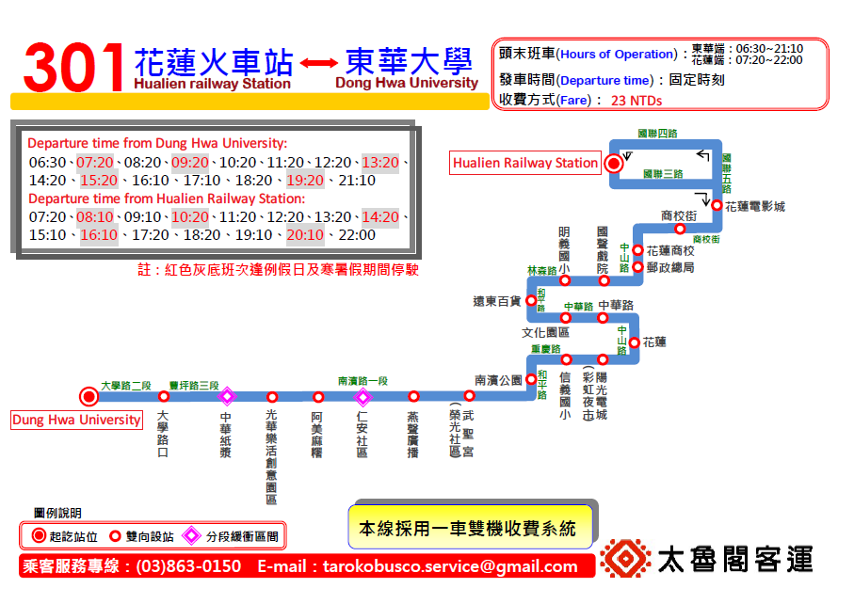

#The timetable will be updated if there is any change.